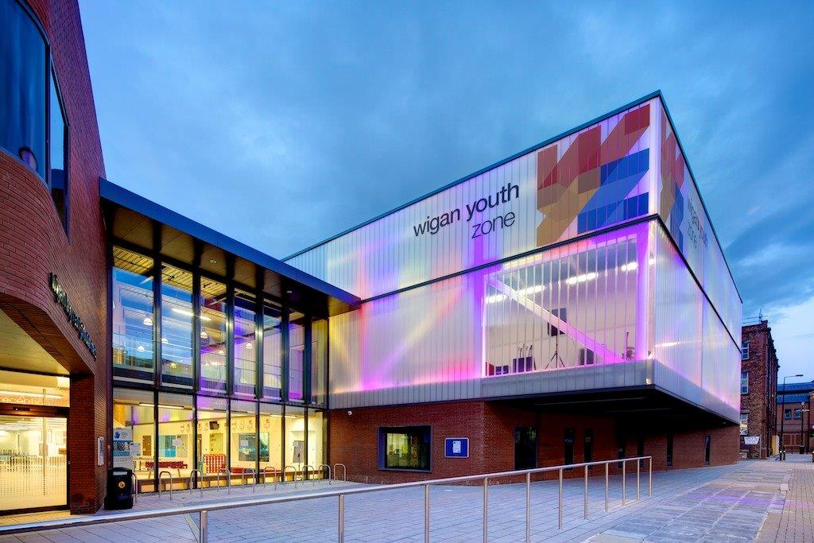

|  |  |  |  |  |
| --- | --- | --- | --- | --- |
|  | | | | |
|  |  | | |  |
| Facilities support operative | | | | |
|  | | Job Description |  | |

|  |  |  |
| --- | --- | --- |
|  | |  | | --- | | OVERVIEW |   **COMPANY:** Wigan Youth Zone  **LOCATION:** Wigan Youth Zone  **SALARY:** £11.65 per hour  **BENEFITS:**   * 33 days annual leave (including bank holidays) pro rata. Plus additional leave for length of service. * Hybrid work, * Birthdays off, * Gym access, * training and CPD including first aid, safeguarding and health and safety, * Career development opportunities, * Employee assistance programme, * Cycle to work scheme, * Strong team culture, * Workplace pension, * Free eye tests, * Discounted to £2 access to holiday club for WYZ staff.   **POSTED:**  26th July 2024  **CLOSING:**  18th August 2024  **First interviews:** TBA  **Second interviews:** TBA  **SPECIALISM:**  Maintenance/Cleaning  **REPORTS TO:** Facilities Manager  **CONTRACT TYPE:** Permanent  **HOURS:** Part time 20 hours per week  **WORK PATTERN:**  Monday – Friday 10am – 2pm  **Please note**, flexibility will be required to cover annual leave and when we are open for holiday clubs during the 13 weeks of school holidays per year.  **ORGANISATION TYPE:** Charity |

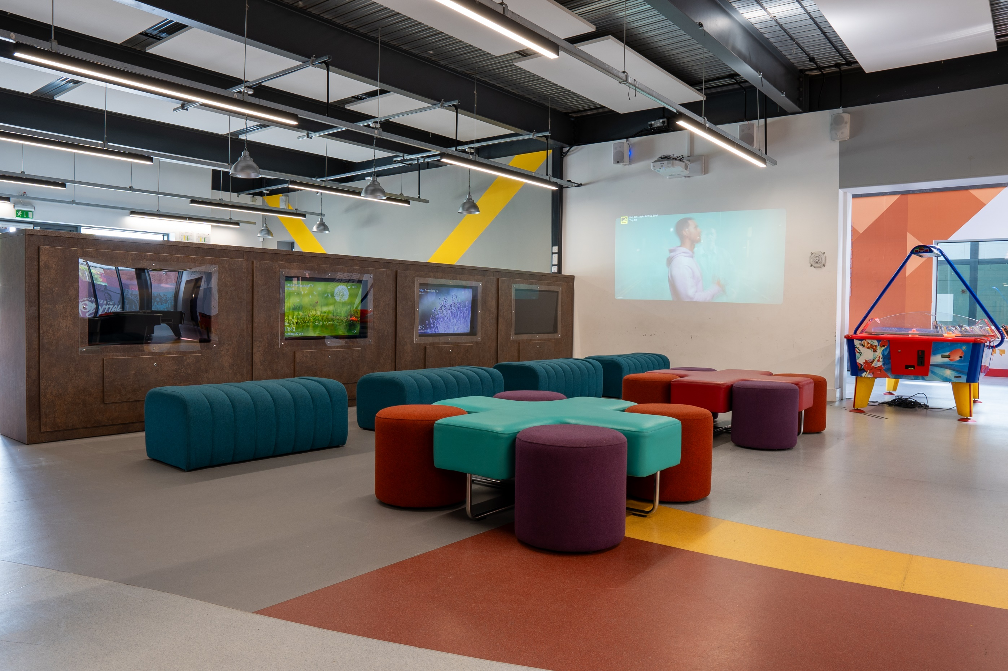

|  |
| --- |
| who we are looking for: |

A self-motivated and systematic individual to provide shift end support to our cleaning team, providing a high standard of cleaning to all areas.

You will be working closely with our Facilities Manager to support reactive maintenance / planned preventative maintenance checks and offer support for event set up and take down.

|  |
| --- |
| Knowledge and Understanding |

Within this supportive role we are looking for an individual who has carried out cleaning duties and minor caretaker-based duties previously. For example, being available for the set-up of events e.g. setting up/taking down tables and chairs and basic staging equipment and someone who is also happy to carry out cleaning duties.

A large part of the role is to support the Facilities Manager in carrying out basic maintenance tasks where an extra pair of hands is crucial, ground maintenance and ensuring waste bins are kept on top of at all times.

Ideally the candidate would need to have a basic understanding of the building checks which need to be carried out to ensure Health and Safety compliance, e.g. legionella / fire alarm tests.

Knowledge of the issues affecting young people and an ability to work with challenging behaviour

Understanding of the principles of working with children and young people

Knowledge of health and safety, diversity awareness and safeguarding best practice and how these relate to children and young people

Level 2 upwards in any basic trade skills – Desirable

First Aid Training – Desirable

IOSH Working safely or Managing Safety at work – Desirable

|  |
| --- |
| What will you need to succeed: |

|  |  |
| --- | --- |
| **EXPERIENCE** |  |
| Previous cleaning experience | Essential |
| Use of cleaning equipment | Desirable |
| Previous experience of facilities management | Desirable |
| Experience of working in a team and alongside volunteers | Desirable |
| **SKILLS** |  |
| Ability to communicate clearly and follow instructions | Essential |
| Ability to prioritise work and manage time effectively | Essential |
| Ability to reach, bend, stoop and kneel | Essential |
| Ability to work on own initiative and as part of a team | Essential |
| A team player | Essential |
| Ability to communicate with a wide range of people and relate well to young people | Essential |
| Commitment to the Youth Zone’s mission and values | Essential |
| Able to negotiate and balance competing priorities | Essential |
| Passionate about helping young people access positive activities | Essential |
| A flexible attitude to work and a willingness to perform a variety of duties to ensure an efficient and effective service | Essential |
| Punctual and reliable | Essential |
| **KNOWLEDGE AND UNDERSTANDING** |  |
| Understanding the principles of working with children and young people | Desirable |
| Understanding of issues affecting young people’s lives | Desirable |
| Knowledge of Health and Safety, diversity awareness and safeguarding best practice and how these relate to children and young people | Essential |
| **SPECIAL REQUIREMENTS** |  |
| A willingness to work unsociable hours when required | Essential |
| DBS clearance and committed to Safeguarding young people | Essential |
| The ability and willingness to travel to meetings and events both in the region and beyond | Desirable |
| WHat you will be doing | |

* To be responsible for cleaning areas of Wigan Youth Zone as allocated by the Senior Cleaning Team Member & Facilities Manager or other Senior Level Management;
* Following Handover from Cleaning team the candidate may be required to perform various cleaning activities including cleaning toilets, sanitary fittings and surrounds; spot cleaning of spillages; wiping furniture, ledges, pipes, paintwork, doors and polishing door glass; emptying and cleaning bins; mopping and spray cleaning hard floor surfaces; floor polishing; wiping, polishing and straightening furniture; replenishing supplies in toilets; and moving items of furniture and equipment;
* To operate cleaning machinery for cleaning soft and hard surfaces, such as vacuum cleaners and polishers;
* To wear appropriate personal protective equipment as necessary;
* To use cleaning materials safely and appropriately, as instructed by the Facility Manager, also ensure COSHH safeguarding rules are followed at all times.
* To adhere to environmental rules by checking and closing windows and switch off lights after work;
* To report any emergency maintenance problems, including toilets and other water fixtures, or hazards immediately to Facilities Manager
* To promote and safeguard the welfare of children and young people at all times;
* To be an active member of the team and operate in line with the values and principles of Wigan Youth Zone.

**General**

* To be alert to issues of safeguarding child protection, ensuring the welfare and safety of Youth Zone members is promoted and safeguarded, and to report any child protection concerns to the designated Child Protection Officers using the safeguarding policies, procedures and practice (training to be provided);
* To assist with any promotional activities and visits that take place at the Youth Zone;
* To actively promote the Youth Zone and positively contribute towards increasing Youth Zone membership;
* To adhere to Wigan Youth Zone policies at all times, with particular reference to Health and Safety, Child Protection and Equal Opportunities.

**Other duties**

* To carry out any other duty with the Youth Zone provision and facility operations, and within the competencies of the post holder, as directed by your line manager or a senior manager.

|  |
| --- |
| Special Requirements |

* A willingness to work unsociable hours when required
* DBS clearance and committed to Safeguarding children
* The ability and willingness to travel to meetings and events both in the region and beyond

The job holder will be required to adhere to the Youth Zone’s policies at all times, with particular emphasis on Equal Opportunities and Safeguarding. Attendance at events and conferences will sometimes be required.

*In accordance with our Child Protection and Safeguarding procedures, this position requires an enhanced DBS check and business satisfactory references.*

*Please note that in line with our Safeguarding Policy, you must be age 21 or over to work in our Senior Sessions and 19+ to work on our Junior Sessions and Holiday Clubs. All applicants must also be inactive as members for at least 12 months.*

|  |
| --- |
| what is wigan youth zone? |

Wigan Youth Zone is a purpose built, state-of-the-art youth facility in Wigan town centre which opened in June 2013. It offers young people from across Wigan the opportunity to meet friends, have new experiences, learn new skills and access the support they need to develop and achieve their potential.

The Youth Zone is open to all young people across Wigan aged from 8 to 19 (up to 25 with additional needs), striving to offer something for everyone, regardless of their interests or abilities. With almost 15 dedicated areas to choose from including our four 40-metre floodlit football pitches, art room, music room and climbing wall – there’s something for everyone here at Wigan Youth Zone.

Our aim is simple, to provide the town’s young people with somewhere to go, something to do and someone to talk to.

|  |
| --- |
| You will benefit from: |

Salary: £11.65 per hour

33 days annual leave (including bank holidays) pro-rata,

Additional leave for length of service up to 38 days,

Birthdays off,

Gym access,

Training and CPD including First Aid, Safeguarding and Health and Safety,

Career development opportunities,

Access to our Employee Assistance Programme,

Cycle to work scheme,

Strong team culture,

Work place pension,

Free eye tests.

Discounted to £2 per day access to holiday club for children of WYZ staff

|  |
| --- |
| what do you need to do next |

Please complete our application form following the link below

<https://app.smartsheet.com/b/form/d852810831d84133b4aea32dfb8436af>

# 88% of our Team would recommend Wigan Youth Zone as an employer to their family and friends